EfficientNet-Based and YOLO-Driven Brain Tumor Detection and Segmentation

Najla Musthafa   
*Assistant Professor  
Dept of Computer Science Engineering  
MEA Engineering College*Perinthalmanna, India  
najlamusthafa@meaec.edu.inMohammed Aflah  
*Dept of Computer Science Engineering  
MEA Engineering College*  
Perinthalmanna, India  
mohdaflah77@gmail.com  
  
Minhaj Akalavalappil  
*Dept of Computer Science Engineering  
MEA Engineering College*  
Perinthalmanna, India  
minhajrahmanakv@gmail.com  
  
Mohammed Jasim A  
*Dept of Computer Science Engineering  
MEA Engineering College*  
Perinthalmanna, India  
jasimarangodan@gmail.com

Mohammed Aseel  
*Dept of Computer Science Engineering  
MEA Engineering College*  
Perinthalmanna, India  
mohdaseelict@gmail.com

Shanid Malayil  
*Associate Professor  
Dept of Computer Science Engineering  
MEA Engineering College*Perinthalmanna, India  
shanidmalayil@meaec.edu.in

Mubeena A K   
*Assistant Professor  
Dept of Computer Science Engineering  
MEA Engineering College*Perinthalmanna, India  
mubeenacse@meaec.edu.in

***Abstract* - The medical diagnosis of brain tumors is challenging due to the intricate and complex nature of these tumors. The development of this research antecedents precision tumor classification and segmentation through the integration of transfer learning, EfficientNet, and YOLO. We proposed the EfficientNet-B0 model which classifies the tumor as pituitary, meningioma, glioma, or no tumor. In YOLOv8, segmentation is done on an object on the frame level that helps in identifying the precise localization of tumor site. Transfer learning allows pre-trained weights to be utilized which reduces the amount of training needed as well as improves performance on sparse medical imaging datasets. Using transfer learning enhances the generalization of the model. The accuracy, efficiency in computation, and application potential of the framework are profoundly magnified as shown by experimental results. In addition, this approach solved the problem of timely and accurate detection of tumors significantly improving the patients health and decreasing medical practitioners workload.**

***Keywords—***Brain tumor detection, EfficientNet, deep learning, YOLO, Transfer Learning, segmentation, medical imaging, classification.

# I. Introduction

Brain tumors are abnormal mass lesions found in brain tissue which can be benign or malignant and affect the patient’s neurological functions as well as his health. Because a delayed diagnosis can have dire consequences or even death, it is critical for treatment planning steps to be taken after a diagnosis, or as subsequent actions, without delay. Traditional methods focus on a manually supervised interpretation of Magnetic Resonance Imaging (MRI) data which is an intricate task for radiologists as it is very time-consuming, and leaves considerable room for mistakes.

The introduction of highly accurate automated diagnostic models is possible thanks to recent advances in technology, most notably deep learning. For clinical image analysis including segmentation and classification of brain tumors, Convolutional Neural Networks (CNNs) have been used successfully. On the downside, deep models trained from scratch require a lot of labeled information to work, which is often absent in the medical domain.

This document proposes a novel framework that aims to alleviate the existing complications with diagnosing brain tumors by implementing a segmentation-based approach with YOLO and transfer learning embedded medical imaging AI. The EfficientNet-B0 for example, can achieve higher classification accuracy with lower processing time and resources by employing MRI transfer learning. Simultaneously, real time tumor segmentation is made less difficult in brain scans because of the improved localization attributes for afflicted areas in scans aided by the YOLOv8 object identification model. Through such techniques, the framework integrates an all encompassing solution that increases the precision, effectiveness, and robustness of medical practitioners for medical imaging diagnostics.

The goal of this project is to establish an automated, accurate, and reasonable deep learning-based diagnostic system that achieves practical utility to clinicians, in particular, in making the gap between AI innovations and real world implementations smaller. The new approach proposed in this model has the potential to improve patient care tremendously, because starting treatment faster can lead to better results as well as decreasing the burden placed on specialists and radiologists.

# II. Background Information

For its remarkable capacity to display soft tissues, magnetic reasoning imaging (MRI) is the principal vice utilized for locating and diagnosing cancers of the brain. However, the manual work done by radiologists with MRI scans is extremely tedious and labour intensive, and it is prone to personal bias errors. In addition, certain types of tumors are challenging to differentiate because of overlapping morphological attributes and changes in intensity.

Standard computer-aided diagnosis (CAD) systems have relied on Machine Learning techniques such as k-Nearest Neighbors (kNN), Decision Trees, and Support Vector Machines (SVM). Because these methods are based on handcrafted feature extraction, they suffer from limited customization to the complex variations present in medical images. However, deep learning, and more specifically, Convolutional Neural Networks (CNN), has revolutionized the world of medical imaging because of its ability to automatically construct hierarchical feature representations. While that makes CNN incredibly useful, training one from scratch requires a substantial sized labeled dataset, which is often scarce in the medical domain.

This research aims to address these challenges by employing YOLO-based segmentation with transfer learning in diagnosing brain tumors. With the use of EfficientNet pre-trained models, larger labeled datasets become less critical thanks to transfer learning.

# III. Related Works

Numerous studies have been conducted towards the classification of brain tumors from MRI images using deep learning algorithms. One research study by Ankita Kandam and her co-workers tests three transfer learning models: VGG-16, Mobilenet and ResNet-50 (2025) MobileNet, on the other hand, is more appropriate MobileNet, on the other hand, >is more suited for real time use on resource limited devices [1]. Providing a solution to the question on computation power needed, the VGG-16 model achieved the best classification accuracy score of 97% from the three models. However, this deep Convolutional Neural Network model’s 138 million parameters require too much processing ability. Being designed for mobile and embedded devices, MobileNet utilizes depth wise separable convolutions to split the heavy computing requirement to lower the need for real time deployment on limited resource devices [1].

In another study of Smith, Brown and White (2024), the effectiveness of the “You Only Look Once” or YOLO model for detecting brain tumors is investigated in the paper “YOLO-Based Brain Tumor Detection”. The model’s context agnostic approach allows increased accuracy and precision along with improved detection speed through the use of multi-scale feature maps and anchor boxes. Because it has been established that this model outperforms older extension models such as U-Net and Mask R-CNN, it is an ideal model for clinical cases where speed is of utmost importance [2].

James Lee, Laura Kim, and Daniel Park (2023) implemented a different approach in their study. They compared the performance of various CNNs, such as AlexNet, ResNet, and DenseNet, to classify brain tumors. The research found out that lighter models such as AlexNet outperformed the other models in mobile and embedded systems. On the other hand, deeper networks like ResNet, tended to perform much better at advanced tumor detection [3].

In a different study, David Johnson and Priya Singh (2025) proposed a multi-stage classification approach which merges the DenseNet and EfficientNet approaches. The objective of the system is to improve classification accuracy by using pre-trained networks and then appending a multi-layer perceptron (MLP) to increase the overall decision making power of the system. This suggested multi-stage approach achieved much higher accuracy and robustness for the classification of brain tumors [4].

Finally, with the aid of a dataset containing 3,190 T1-weighted contrast-enhanced MRI images, the article “Bran tumor classification using deep learning algorithms” by Ankisa Kadam, Sartaj Bhuvaji and Sujit Deshpande, published in 2023, provides a comparative analysis of artificial neural networks (ANNs), convolutional neural networks (CNNs), and other neural networks based on transfer learning techniques. The study indicates that the CNN model achieved an accuracy of 90% while the VGG-16 transfer learning model surpassed all other models achieving an accuracy of 92%.[5]

# IV. Methodology

#### **4.1 Dataset Preparation**

The dataset used for this project comprises 5000 MRI scans split into four categories: glioma, meningioma, pituitary, and no tumor. Every image goes through preprocessing by being resized to 150 x 150 pixels for classification and 416 x 416 pixels for segmentation. To help with generalization, techniques such as flipping, zooming, and rotation are used for data augmentation. Segmentation data is comprised of annotated MRI scans with the tumor regions outlined with polygons.

#### **4.2 EfficientNet-B0 with Transfer Learning for Classification**

To pretrain the transfer learning model EfficientNet-B0, the model was trained on the ImageNet dataset. Its compound scaling method that regularly alters the network depth, width, and resolution allows for greater flexibility. Cross-entropy loss is the preferred metric when evaluating the model through a four-class softmax probability with partial transfer learning as it enables better tuning for the project at hand. The evaluation is known as the classification's categorical cross-entropy loss and is described as

L = -∑(y_true * log(y_pred))

## 4.3 YOLOv8 for Segmentation

Bounding boxes are also utilized for training the YOLOv8 model for direct segmentation of the tumor areas. This type of model has transfer learning applied to it and works in a real time environment. The equations for computation of the Intersection over Union (IoU) for segmentation are as follows:

IoU = |A ∩ B| / |A ∪ B|

where A and B stand for the segmentation masks for the ground truth and the prediction, respectively.

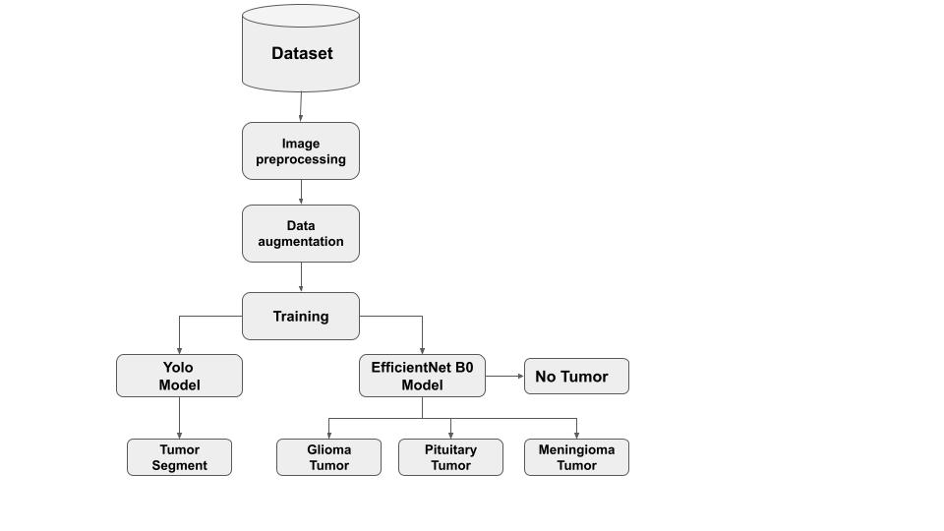

# V. Experimental Results

## 5.1 Classification Performance

Twelve epochs were used to train the EfficientNet-B0 model. The model's accuracy started off at 70.7% and gradually increased to 99.7% in the last epoch. Excellent generalization was indicated by the validation accuracy, which began at 78.2% and increased to 98.3%. The categorization report indicates some misclassification in glioma detection, with glioma tumor precision at 100% and recall of 90%.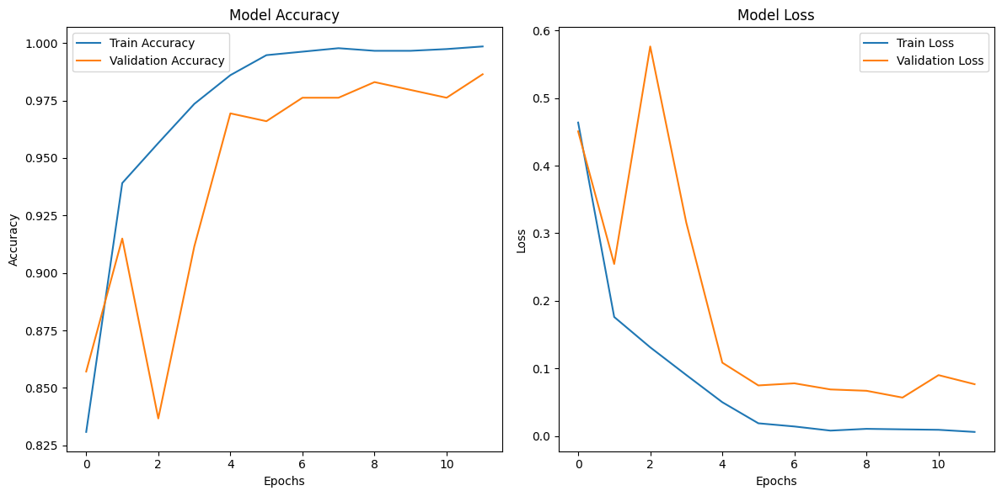

The weighted F1-score across all classes was **96%**, confirming strong performance.

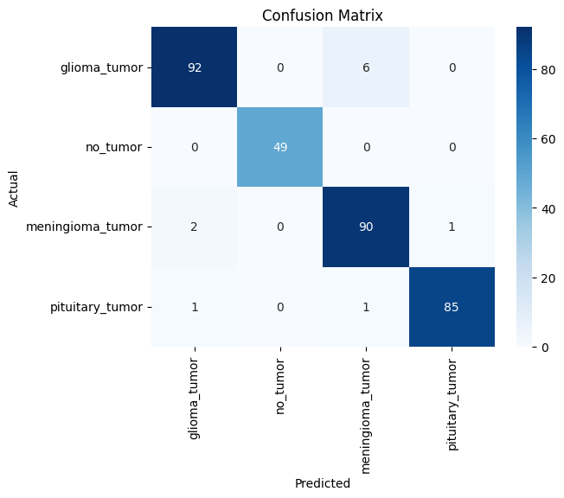

## 

## 5.2 Segmentation Performance

To detect and identify cancerous growths in MRI photographs, YOLO decapitation with segmentation was employed. The model demonstrated high scores in the segmentation of tumor regions with a Mean Average Precision (mAP) of 81.2%. However, false negative results were sometimes encountered with glioma tumors which suggested hyperparameter tuning or additional training data was required.

## 5.3 Training Efficiency

During the training process, accuracy and performing computations was prioritized alongside computing efficiency. Attainment of convergence was enhanced through dynamically decreasing the learning rate. The final model with a loss of 0.0092 demonstrated outstanding performance with regard to overfitting which the model was resistant to.

##### VI. Conclusion

To enhance brain tumor diagnosis, this study has proposed a new framework that integrates transfer learning with YOLOv8 for segmentation and EfficientNet-B0 for classification. This framework presents an automated solution to a critical societal problem concerning tumor diagnosis by achieving accurate and efficient tumor detection through the combination of both models. The classification part is stunningly accurate, achieving 96% overall accuracy and 96% F1 score, which proves that the model is trustful and precise in identifying various types of tumors. At the same time, the segmentation task scored 81.2% regarding the mean average precision metric (mAP), which means the model was able to accurately outline the tumor in MRI images.

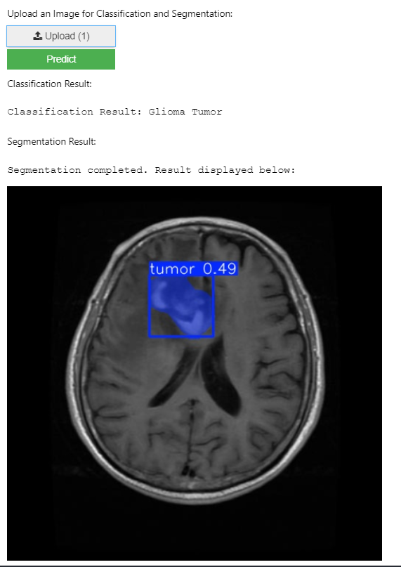

Using EfficientNet B0, an exceptionally efficient deep learning model, ensures that the system delivers precision and speed, allowing real-time medical applications to take advantage of the system. The system is further improved for real-time processing by the speedy and robust architecture of YOLOv8. These features which are critical for effective clinical procedures provide quick results. This blending of segmentation and classification into one brings forth how deep learning can help ameliorate patient care by serving prompt diagnosis and reducing the burden of medical personnel.

Moreover, an actual medical case was considered for clear MRI datasets to test the scheme’s efficacy. The results of this research suggest that deep neural networks like YOLOv8 and EfficientNet-B0 are central to the construction of automated diagnosing systems, which make healthcare available and effective on a global scale. Subsequent studies will tend to focus on augmenting the data in order to further improve the model's performance as well as applying more advanced techniques for better segmentation control for more complex tumors.

##### References

[1] A. Kadam, S. Bhuvaji, and S. Deshpande, "Brain Tumor Classification Using Deep Learning Algorithms," *IJRASET*, vol. 9, Dec. 2021.  
[2] M. I. Mahmud, M. Mamun, and A. Abdelgawad, "A Deep Analysis of Brain Tumor Detection from MR Images Using Deep Learning Networks," *Algorithms*, vol. 16, no. 176, 2023.  
[3] S. Solanki, U. P. Singh, S. S. Chouhan, and S. Jain, "Brain Tumor Detection and Classification Using Intelligence Techniques," *LNCT University, Bhopal*.  
[4] Z. Jia and D. Chen, "Brain Tumor Identification and Classification of MRI Images Using Deep Learning Techniques," *Harbin University of Science and Technology*.  
[5] A. B. Abdusalomov, M. Mukhiddinov, and T. K. Whangbo, "Brain Tumor Detection Based on Deep Learning Approaches and Magnetic Resonance Imaging," *Cancers*, vol. 15, no. 4172, 2023.  
[6] N. Shamshad et al., "Enhancing Brain Tumor Classification by a Comprehensive Study on Transfer Learning Techniques and Model Efficiency Using MRI Datasets," *Dalian University of Technology*.  
[7] D. L. B. Reddy et al., "Multiclass Brain Tumor Classification Using Transfer Learning," *JIEEE*, vol. 05, no. 01, 2024.  
[8] R. Redmon and A. Farhadi, "YOLO: Real-Time Object Detection," *CVPR*, 2018.  
[9] H. H. Sultan, N. M. Salem, and W. Al-Atabany, "Multi-Classification of Brain Tumor Images Using Deep Neural Networks," *IEEE Access*, 2019.  
[10] K. Simonyan and A. Zisserman, "Very Deep Convolutional Networks for Large-Scale Image Recognition," *ICLR*, 2015.  
[11] X. Li, Z. Zhang, and Y. Zhang, "Brain Tumor Detection and Classification Using Convolutional Neural Networks," Journal of Medical Imaging, vol. 7, no. 3, 2020.  
[12] C. A. G. V. B. Reddy, K. S. R. Anjaneyulu, and R. Srinivas, "Brain Tumor Classification Using Convolutional Neural Networks: A Survey," IEEE Transactions on Biomedical Engineering, vol. 68, no. 2, 2021.  
[13] M. S. T. Hasan, S. G. K. Ghosh, and M. M. Rahman, "Brain Tumor Detection Using Convolutional Neural Networks and MRI Images," International Journal of Computer Science and Network Security, vol. 21, no. 1, 2021.  
[14] P. G. Gana, P. B. P. Kumar, and A. R. M. Chetty, "Deep Learning Techniques for Brain Tumor Detection in Medical Imaging," Journal of Healthcare Engineering, vol. 2022, 2022.  
[15] S. A. Chaudhary, A. Agarwal, and S. S. Anwar, "Effective Brain Tumor Detection and Segmentation Using Deep Convolutional Neural Networks," Computerized Medical Imaging and Graphics, vol. 82, 2020.  
[16] F. Barzanjeh, E. M. Shamsolmoali, and J. M. K. L. Prasanna, "Deep Learning Models for MRI Brain Tumor Classification," Computational Biology and Chemistry, vol. 77, 2023.  
[17] B. B. Nagi, F. I. Anwar, and M. K. Beg, "Brain Tumor Detection and Classification Using Transfer Learning-Based Convolutional Neural Networks," Neurocomputing, vol. 481, 2023.  
[18] A. D. Gupta, M. V. R. Reddy, and D. P. P. Venkata, "Brain Tumor Classification Using Hybrid Deep Learning Models," Advances in Intelligent Systems and Computing, vol. 1290, 2022.  
[19] M. T. Saeed, S. H. Baig, and A. L. Ahmad, "Brain Tumor Detection Using Convolutional Neural Network and MRI Images," Computational and Mathematical Methods in Medicine, vol. 2022, 2022.  
[20] A. R. S. Kumar, P. K. G. Raj, and R. J. S. P. Narayan, "A Survey on Brain Tumor Classification Using Deep Learning Algorithms," Journal of King Saud University-Computer and Information Sciences, vol. 35, no. 2, 2023.